ART & DESIGN | ART REVIEW

A Groundbreaking Show Presents a New, Inclusive Vision of American Art

OUTLIERS AND AMERICAN VANGUARD ART

- NYT Critic’s Pick
By ROBERTA SMITHFEB. 15, 2018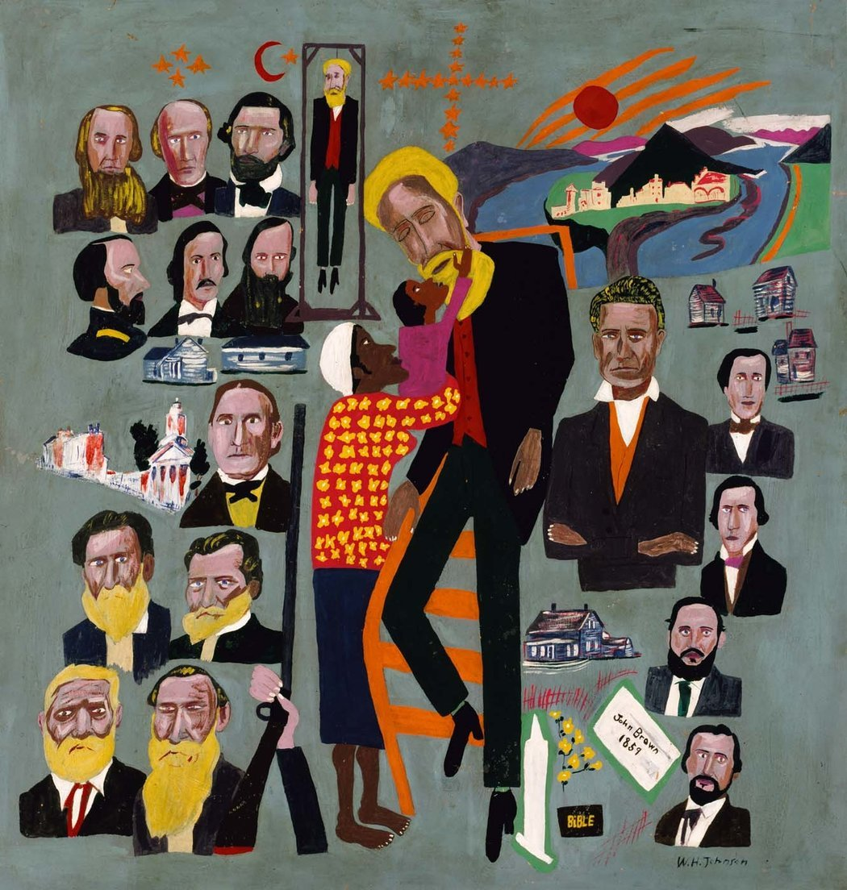
William H. Johnson’s “John Brown Legend,” circa 1945, makes the abolitionist its central image and shows him coming down from a cross and being greeted by a mother and her child. This rarely exhibited work is part of “Outliers and American Vanguard Art,” at the National Gallery.CreditSmithsonian American Art Museum, via National Gallery

WASHINGTON — Anyone interested in American modernism should see “Outliers and American Vanguard Art” at the National Gallery of Art. Flaws and all, this groundbreaking adventure highlights outstanding, sometimes rarely-seen artworks; revives neglected histories; and reframes the contributions of self-taught artists to this country’s rich visual culture.
In recent decades the greatness of these marginalized artists has become increasingly undeniable — whether you call their work folk, primitive, amateur, naïve or, lately, outsider — and demands have gotten louder to include them in a more flexible integrated version of modernism.
The show’s predecessors include ambitious surveys like “Parallel Visions: Modern Artists and Outsider Art” at the Los Angeles County Museum of Art in 1993 and “The Encyclopedic Palace of the World,” at the 2013 Venice Biennale. But “Outliers” is different. Limiting its scope to American art, it tries to map the intersections of taught and untaught over the last century, examining not only the place of self-taught art now but how it got here.
“Outliers” represents some five years of meticulous research by Lynne Cooke, senior curator for special projects in modern art at the National Gallery. It is extensive: about 280 artworks by 84 artists — and Ms. Cooke has organized them chronologically, in three sections. Each examines a period when mainstream artists and curators were especially involved with self-taught: 1924-43, 1968-92 and 1998-2013.
On display are little-seen masterpieces like William H. Johnson’s proto-Pop painting “John Brown Legend,” from about 1945 and part of the artist’s final series, “Fighters for Freedom.” It centers on the martyred white abolitionist as he comes down from a cross, while a black mother holds up her child to tenderly touch his face. Arrayed around them float emblems of religion and American history: a church, a Bible and a golden city; portraits of white men, mostly of Civil War vintage; log cabins; and a half-length portrait that may depict the artist.
Photo
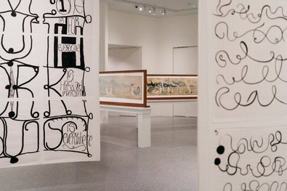
Matt Mullican’s “Three Suitcases of Love, Truth, Work and Beauty” (2006), in the foreground, frame Henry Darger’s illustrated works about the Vivian Girls.CreditJustin T. Gellerson for The New York Times

Elsewhere, the show affirms that black self-taught artists from the South created — in context, innovation and the ability to influence — the visual equivalent to gospel music and the blues. It also acknowledges the amazing run of self-taught geniuses that emerged from the late 1960s into the ’90s — from Martín Ramírez (1895-1963), the Mexican laborer who created his world of caballeros, arcades and Madonnas in a mental hospital in Northern California from the late 1940s to the early ’60s, to James Castle (1899-1977), a deaf-mute artist who depicted the world of his family’s Idaho farms (including his own art) in many shades of gray, and Morton Bartlett (1909-1992), known for his photographs of his anatomically correct child mannequins. And you’ll find juxtapositions of taught and self-taught artists that are, for the most part, mutually illuminating in their forms and themes.

Ms. Cooke’s show is about art, but also exhibitions of art. She measures the art-world’s inconsistent attention to self-taught art in terms of the ebb and flow of group exhibitions in museums and elsewhere. This befits, she writes in the catalog, a “field whose history has been fundamentally shaped by exhibitions.”
Photo
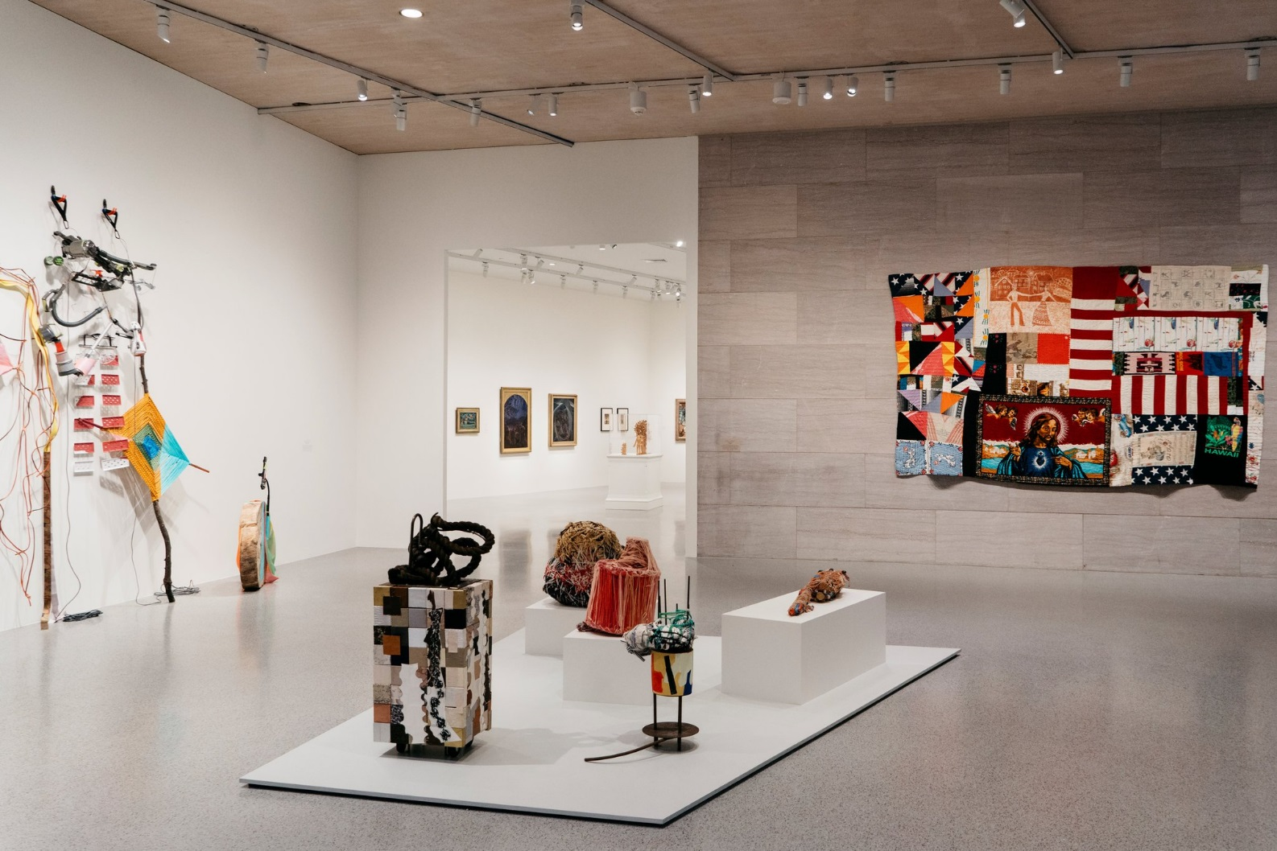
From left: Jessica Stockholder’s “Between the Lines,” from 2017; center, sculptures by Nancy Shaver (forefront) and Judith Scott (background); and a quilt by Rosie Lee Tompkins that is made of found fabrics, including segments of an American flag and a towel depicting Jesus. CreditJustin T. Gellerson for The New York Times

“Outliers” opens with a two-walled area featuring four artists, carefully, and promisingly, positioning together taught and self-taught artworks of relatively recent vintage united by color, found materials and a degree of abstraction. Three works by the outsider sculptor Judith Scott (1943-2005), known for creating evocative misshapen presences by wrapping found objects in layers of yarn , share a low platform with the work of the mainstream artist Nancy Shaver, whose delicate assemblage-boxes covered with found papers and fabrics, resemble folk-art updates. An airy assemblage by Jessica Stockholder, also mainstream, takes elegant charge of one wall. On another hangs a large provocative quilt by Rosie Lee Tompkins (1936-2006) made of found fabrics, including segments of an American flag and towels, one depicting Jesus. It has the bold color and scale of a James Rosenquist Pop art painting.
That is just the overture. Because of the volume of material here, it’s best to view the show the way Ms. Cooke intended, by tackling the three periods chronologically.

1924 to 1943: Folk Aesthetics Reconfigured
Photo
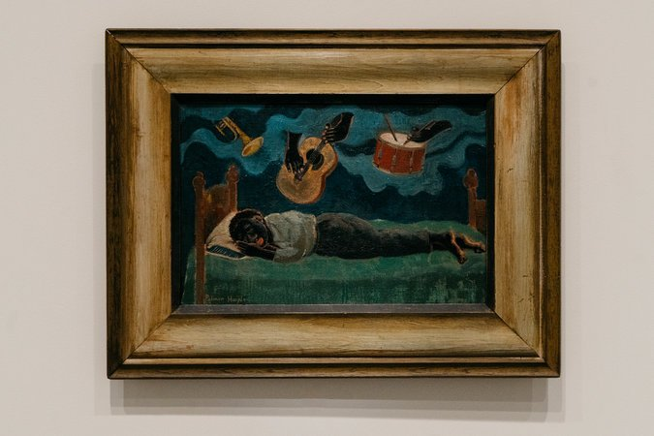
Palmer Hayden “Untitled Dreamer,” from around 1930. CreditJustin T. Gellerson for The New York Times

This section traces the growing understanding of folk art’s formal simplicity as implicitly modern. It includes the work of trained artists who were early appreciators, among them, Charles Sheeler, Yasuo Kuniyoshi, Marsden Hartley, Florine Stettheimer and Elie Nadelman. There are also unfamiliar works that mesmerize, including two from around 1930: “Adam and Eve and the Garden,” a carved wood tableau by José Dolores López that buzzes with medieval sprightliness, and Palmer Hayden’s “Untitled (Dreamer),” which depicts a black man sleeping in a pose and simplified style reminiscent of both Henri Rousseau and Paul Gauguin. The man’s head rests sweetly on a fringed pillow, while a trumpet, a guitar and a drum are played by disembodied hands.
The Museum of Modern Art collected and exhibited some of the self-taught artists found here under the leadership of its founding director, Alfred H. Barr Jr. — a folk-art true believer. Perhaps the most surprising is the presence of work by Edward Hicks, the early-19th-century Quaker painter of sentient animals, including a “Peaceable Kingdom,” from about 1834, similar to the one the Modern once owned.
Photo
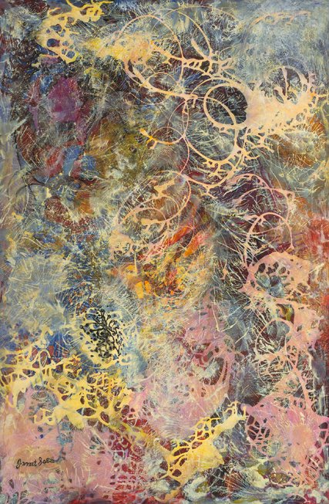
“Milky Way,” a 1945 dripped-paint abstraction by Janet Sobel.CreditThe Museum of Modern Art/Licensed by SCALA, via Art Resource, NY

At times the allegiance to chronology curtails chances to surprise. Lonnie Holley’s wonderful 1985 sculpture in carved sandstone is marooned just outside the show; it should have been with its (mostly) 1930s precursors, among the carved stone sculptures of William Edmondson and John B. Flanagan whose pairing is by now a bit tired. And there are strange missed opportunities: “Milky Way,” a luminous dripped-paint abstraction from 1945 by the self-taught Ukrainian-American artist Janet Sobel, should have been paired with one by Jackson Pollock (who was aware of her work). But Ms. Cooke consistently skirts canonical figures; her vanguard artists are also in different ways outliers, except for art stars like Kara Walker and Cindy Sherman, both of whom appear later without much justification, though Ms. Sherman collects and has written about some of the outsider photographers grouped around her.

1968-1992: Commensurables and Incommensurables
Photo
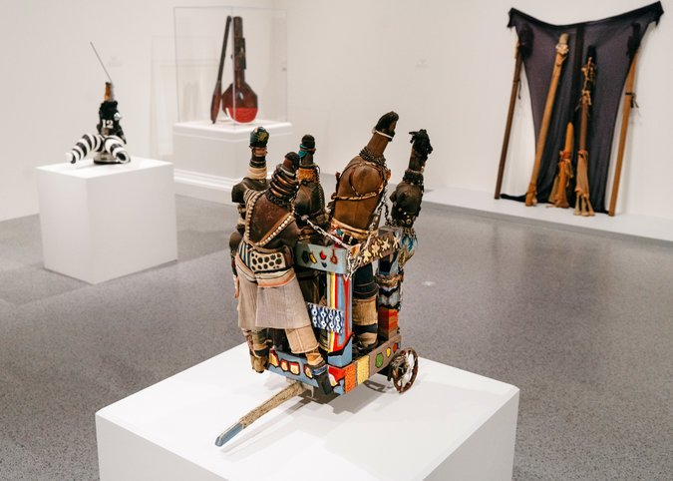
Works from the 1968 to 1992 period include, forefront, John Outterbridge’s “Captive Image #1” from 1971-72. And clockwise from far left: Mr. Outterbridge’s “Captive Image #4” (circa 1974-76); Betye Saar’s “Sambo’s Banjo” (1975); and “Untitled” (1976) from Senga Nengudi.CreditJustin T. Gellerson for The New York Times

The second section gives the show a combustible center; its title alludes to the debate over whether self-taught artists could be compared to trained ones or are incomparable. “Outsider art” supersedes “folk art,” connoting a more jarring, free-range aesthetic usually from outside the Northeast, as demonstrated here. Starting in an almost too spacious gallery this section contains the most intense visual conversations between taught and self-taught.
First, it’s between the idiosyncratically figurative Chicago Imagists (Roger Brown, Jim Nutt, Gladys Nilsson) and some of the outsider greats they discovered, recovered or championed: Ramírez, Joseph Yoakum and P.M. Wentworth. The back and forth between Brown’s meticulous landscape forms and Yoakum’s is especially rewarding.
Next, there is also a dialogue regarding visceral materials and sometimes painful themes between self-taught and taught African-American artists. The first group gained wider attention with “Black Folk Art in America: 1930-1980,” a landmark exhibition at the Corcoran Gallery of Art in 1982. They included David Butler (1898-1997), who fashioned animals, angels and people from cut and painted tin and other found items; the religious painter Sister Gertrude Morgan (1900-1980); Steve Ashby (1904-1980), who made raw figurative assemblages out of scavenged materials; and Elijah Pierce (1892-1984), whose carved and painted wood reliefs depict biblical scenes and national figures like the Rev. Martin Luther King Jr.
Then the show turns to work by the second group, an imposing cadre of trained artists working in Los Angeles like Betye Saar, John Outterbridge, Senga Nengudi and Noah Purifoy, who worked for decades at the margins of the mainstream, exploring aspects of assemblage and found materials as well as political expression in often abstract forms.

1998-2013: Determining Difference Differently
Photo
Greer Lankton’s dolls, which she used to allude to her transition to womanhood and celebrate various kinds of glamorous icons, including the first lady Jacqueline Kennedy.CreditJustin T. Gellerson for The New York Times

The show starts to unravel as it rushes through its final section, despite the title’s koan-like optimism. Mr. Holley’s two delicate assemblages may make you yearn for something bigger and more ferocious from this versatile Southern outsider, and also for the obstreperous painted or rusted metal reliefs by his friend Thornton Dial, who is inexplicably absent. Two formally educated artists especially make sense in the “outlier” zone. One is Greer Lankton, whose drawings, photographs and dolls allude to her transition to womanhood and celebrate various glamorous icons, including the first lady Jacqueline Kennedy, who remains unforgettably elegant amid tragedy, in the famous pink Chanel suit she wore on Nov. 22, 1963. The other is Matt Mullican, whose large drawings on paper-backed bedsheets covered with numbers, words and images has a “drawing in tongues” quality, and were partly achieved through hypnosis. It is however unclear what — besides being two-sided — his work has to do with the big watercolors of the towering outsider talent Henry Darger (1892-1973), whose illustrated epic about the Vivian Girls used enlarged images from children’s coloring books and would be better compared with Warhol.
In the last gallery you can revel in the vibrant geometric quilts of Mary Lee Bendolph and Annie Mae Young, who emerged in the rapturously received exhibition “The Quilts of Gee’s Bend,” which toured the country in 2002. Also here are two more quilts, made of small irregular squares of color, by the great Rosie Lee Tompkins. Ms. Tompkins may belong to the string of geniuses who emerged in the last three decades of the 20th century. But who knows, there always seem to be more, expanding and improving the story of American art.

Looking for More Information? Here’s a History
Photo
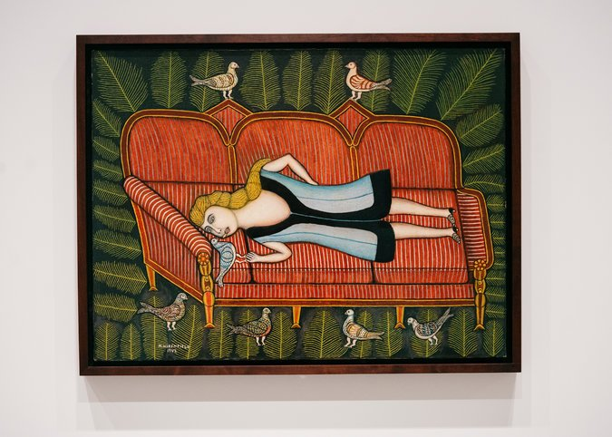
Morris Hirshfield’s “Girl With Pigeons,” part of the exhibition “Outliers and American Vanguard Art,” is in the Museum of Modern Art’s collection. CreditJustin T. Gellerson for The New York Times

The first section of “Outliers and American Vanguard Art” includes a memorable glimpse of the MoMA’s early devotion to self-taught artists. This involvement is known, but seeing it made flesh with wonderful works of art is a different order of magnitude — at once exciting and saddening. We see a museum that might have been: more open and democratic, less bound up in the rigid Francophile narrative that defined the Modern in the later decades of the 20th century.
Barr, the museum’s founding director, viewed self-taught and educated art as equally essential to 20th-century modernism. Ultimately, this didn’t sit well with the museum’s blue-blooded trustees, and it was among the main reasons he was fired in 1943.
Barr, who might well have embraced the “outliers” term, is the de facto hero of Ms. Cooke’s National Gallery exhibition: a historic figure and early adopter of the integration that her exhibition proposes. It’s enticing to consider how different the Modern and the art world might be had his directorship continued. “Outliers” and its predecessors might not even have been necessary.
During the 1930s and early 1940s, Barr and his curatorial staff mounted several shows of self-taught artists and included them in more general exhibitions. Rousseau, the French naïve painter who is represented in “Outliers” by three silent, hallucinatory canvases, was arguably the cornerstone of Barr’s self-taught faith. An American favorite was John Kane, known for his dense paintings of life and industry in and around Pittsburgh, like the one in “Outliers,” and also for his startling 1929 self-portrait. One of six Kanes still in the Modern’s collection, it shows a bare-chested strongman going soft, seemingly deified by three thick white bands that frame his head.
One of the “MoMA-owns-this?” surprises in “Outliers” is Dominique-Paul Peyronnet’s “The Ferryman at Moselle,” from around 1934. This polished vignette freezes forever a moment from World War I: its protagonist has just cut the ferry’s rope, capsizing his boat and its load of German soldiers while others watch from the bank. A great artist who got away is also here: a dozen of Bill Traylor’s taut silhouettes of town and farm life. Barr tried to buy a group of Traylors in 1941 for such a pittance that his offer was spurned. No one gets every great thing that comes along, not even Alfred Barr.
In 1941, a new installation of the museum’s permanent collection began with a gallery of “modern primitives,” but Barr’s time was running out. One of the last straws was an exhibition of the paintings of the retired tailor Morris Hirshfield, represented in “Outliers” by “Girl With Pigeons” (1942), which shows a statue-like figure reclining on a splendid red couch. Today the most prominent vestige of Barr’s folk-art advocacy is Rousseau’s work, such a familiar part of the Modern’s identity that it barely registers as “self-taught.”
Outliers and American Vanguard Art
Through May 13 at the National Gallery of Art, Washington; 202-737-4215, nga.gov. The show will be at the High Museum of Art in Atlanta from June 24 to Sept. 30, and the Los Angeles County Museum from Nov. 18 to March 18, 2019.

